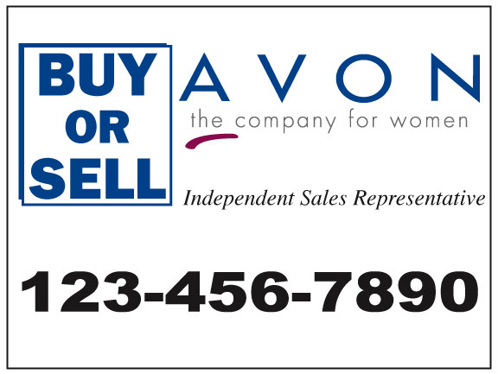
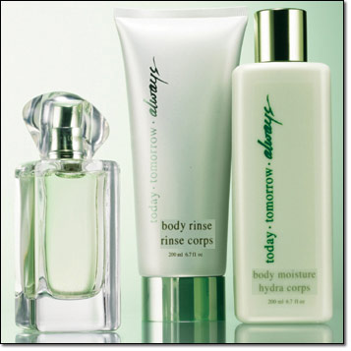

Have you ever desired to be your own boss? Well, here is your opportunity to own your own business. As an independent AVON representative you are able to have:
A Profitable Home-Based Business
Unlimited Earnings
Personal and Professional Growth
Recognition and Rewards
Create Your Own Hours
Help Others to Realize Their Dreams

At AVON you are in business for Yourself, not by Yourself. AVON and I will be partners in helping you achieve your dreams.

It’s easy to succeed; all it takes is a dream and a $10 initial investment.

Please give me a call at so we can discuss the AVON Opportunity of Selling-Sharing-Showing with you

Become an AVON Independent Sales Representative!
Only $10 to start!
THE COST OF LUNCH…COULD CHANGE YOUR LIFE
You are guaranteed 50% earnings on your first
four orders of $50 or more!
Set your own hours! Unlimited earnings! Work from home! No inventory to keep!
Call today!
Phone:

